**Assignment - 4**

**1. Create a general class ThreeDObject and derive the classes Box, Cube, Cylinder and Cone from it. The class ThreeDObject has methods wholeSurfaceArea( ) and volume( ). Override these two methods in each of the derived classes to calculate the volume and whole surface area of each type of three-dimensional object. The dimensions of the objects are to be taken from the users and passed through the respective constructors of each derived class. Write a main method to test these classes.**

import java.util.Scanner;

class ThreeDObject {

public double wholeSurfaceArea() {

return 0.0;

}

public double volume() {

return 0.0;

}

}

class Box extends ThreeDObject {

private double length;

private double width;

private double height;

public Box(double l, double w, double h) {

length = l;

width = w;

height = h;

}

public double wholeSurfaceArea() {

return 2 * (length * width + width * height + height * length);

}

public double volume() {

return length * width * height;

}

}

class Cube extends ThreeDObject {

private double side;

public Cube(double s) {

side = s;

}

public double wholeSurfaceArea() {

return 6 * side * side;

}

public double volume() {

return side * side * side;

}

}

class Cylinder extends ThreeDObject {

private double radius;

private double height;

public Cylinder(double r, double h) {

radius = r;

height = h;

}

public double wholeSurfaceArea() {

return 2 * Math.PI * radius * height + 2 * Math.PI * radius * radius;

}

public double volume() {

return Math.PI * radius * radius * height;

}

}

class Cone extends ThreeDObject {

private double radius;

private double height;

public Cone(double r, double h) {

radius = r;

height = h;

}

public double wholeSurfaceArea() {

double slantHeight = Math.sqrt(radius * radius + height * height);

return Math.PI * radius * slantHeight + Math.PI * radius * radius;

}

public double volume() {

return Math.PI * radius * radius * height / 3.0;

}

}

public class Main2 {

public static void main(String[] args) {

System.out.println("Name : Gokul Sarkar \nRoll No : 46");

Scanner scanner = new Scanner(System.in);

System.out.print("Enter length, width, and height of a box: ");

double l = scanner.nextDouble();

double w = scanner.nextDouble();

double h = scanner.nextDouble();

Box box = new Box(l, w, h);

System.out.println("The whole surface area of the box is " + box.wholeSurfaceArea());

System.out.println("The volume of the box is " + box.volume());

System.out.print("Enter the side length of a cube: ");

double s = scanner.nextDouble();

Cube cube = new Cube(s);

System.out.println("The whole surface area of the cube is " + cube.wholeSurfaceArea());

System.out.println("The volume of the cube is " + cube.volume());

System.out.print("Enter the radius and height of a cylinder: ");

double r = scanner.nextDouble();

h = scanner.nextDouble();

Cylinder cylinder = new Cylinder(r, h);

System.out.println("The whole surface area of the cylinder is " + cylinder.wholeSurfaceArea());

System.out.println("The volume of the cylinder is " + cylinder.volume());

System.out.print("Enter the radius and height of a cone: ");

r = scanner.nextDouble();

h = scanner.nextDouble();

Cone cone = new Cone(r, h);

System.out.println("The whole surface area of the cone is " + cone.wholeSurfaceArea());

System.out.println("The volume of the cone is " + cone.volume());

scanner.close();

}

}

**Output:**

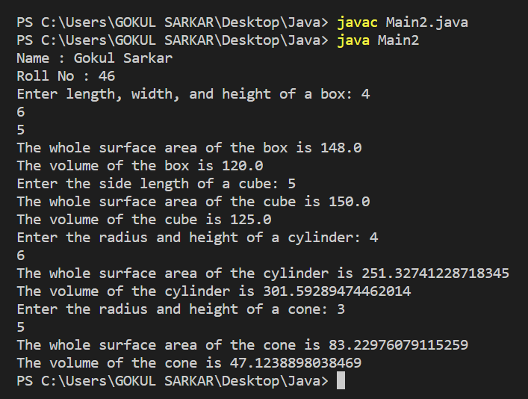

**2.** **Create a base class Building that stores the number of floors of a building, number of rooms and it’s total footage. Create a derived class House that inherits Building and also stores the number of bedrooms and bathrooms. Demonstrate the working of the classes.**

import java.util.Scanner;

class Building {

private int numFloors;

private int numRooms;

private double totalFootage;

public Building(int numFloors, int numRooms, double totalFootage) {

this.numFloors = numFloors;

this.numRooms = numRooms;

this.totalFootage = totalFootage;

}

public int getNumFloors() {

return numFloors;

}

public void setNumFloors(int numFloors) {

this.numFloors = numFloors;

}

public int getNumRooms() {

return numRooms;

}

public void setNumRooms(int numRooms) {

this.numRooms = numRooms;

}

public double getTotalFootage() {

return totalFootage;

}

public void setTotalFootage(double totalFootage) {

this.totalFootage = totalFootage;

}

}

class House extends Building {

private int numBedrooms;

private int numBathrooms;

public House(int numFloors, int numRooms, double totalFootage, int numBedrooms, int numBathrooms) {

super(numFloors, numRooms, totalFootage);

this.numBedrooms = numBedrooms;

this.numBathrooms = numBathrooms;

}

public int getNumBedrooms() {

return numBedrooms;

}

public void setNumBedrooms(int numBedrooms) {

this.numBedrooms = numBedrooms;

}

public int getNumBathrooms() {

return numBathrooms;

}

public void setNumBathrooms(int numBathrooms) {

this.numBathrooms = numBathrooms;

}

}

public class Main3 {

public static void main(String[] args) {

System.out.println("Name : Gokul Sarkar \nRoll No : 46");

Scanner scanner = new Scanner(System.in);

System.out.print("Enter the number of floors, number of rooms, and total footage of a building: ");

int numFloors = scanner.nextInt();

int numRooms = scanner.nextInt();

double totalFootage = scanner.nextDouble();

Building building = new Building(numFloors, numRooms, totalFootage);

System.out.print("Enter the number of bedrooms and bathrooms in a house: ");

int numBedrooms = scanner.nextInt();

int numBathrooms = scanner.nextInt();

House house = new House(numFloors, numRooms, totalFootage, numBedrooms, numBathrooms);

System.out.println("The building has " + building.getNumFloors() + " floors, " + building.getNumRooms() + " rooms, and " + building.getTotalFootage() + " total footage.");

System.out.println("The house has " + house.getNumFloors() + " floors, " + house.getNumRooms() + " rooms, " + house.getTotalFootage() + " total footage, " + house.getNumBedrooms() + " bedrooms, and " + house.getNumBathrooms() + " Bathrooms." );

scanner.close();

}

}

**Output:**

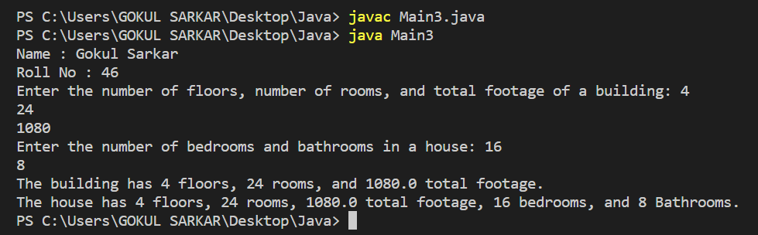

**3. In the earlier program, create a second derived class Office that inherits Building and stores the number of telephones and tables. Now demonstrate the working of all three classes.**

import java.util.Scanner;

class Building {

private int numFloors;

private int numRooms;

private double totalFootage;

public Building(int numFloors, int numRooms, double totalFootage) {

this.numFloors = numFloors;

this.numRooms = numRooms;

this.totalFootage = totalFootage;

}

public int getNumFloors() {

return numFloors;

}

public void setNumFloors(int numFloors) {

this.numFloors = numFloors;

}

public int getNumRooms() {

return numRooms;

}

public void setNumRooms(int numRooms) {

this.numRooms = numRooms;

}

public double getTotalFootage() {

return totalFootage;

}

public void setTotalFootage(double totalFootage) {

this.totalFootage = totalFootage;

}

}

class Office extends Building {

private int numTelephones;

private int numTables;

public Office(int numFloors, int numRooms, double totalFootage, int numTelephones, int numTables) {

super(numFloors, numRooms, totalFootage);

this.numTelephones = numTelephones;

this.numTables = numTables;

}

public int getNumTelephones() {

return numTelephones;

}

public void setNumTelephones(int numTelephones) {

this.numTelephones = numTelephones;

}

public int getNumTables() {

return numTables;

}

public void setNumTables(int numTables) {

this.numTables = numTables;

}

}

public class Main4 {

public static void main(String[] args) {

System.out.println("Name : Gokul Sarkar \nRoll No : 46");

Scanner scanner = new Scanner(System.in);

System.out.print("Enter the number of floors, number of rooms, and total footage of a building: ");

int numFloors = scanner.nextInt();

int numRooms = scanner.nextInt();

double totalFootage = scanner.nextDouble();

Building building = new Building(numFloors, numRooms, totalFootage);

System.out.print("Enter the number of telephones and tables in an office: ");

int numTelephones = scanner.nextInt();

int numTables = scanner.nextInt();

Office office = new Office(numFloors, numRooms, totalFootage, numTelephones, numTables);

System.out.println("The building has " + building.getNumFloors() + " floors, " + building.getNumRooms() + " rooms, and " + building.getTotalFootage() + " total footage.");

System.out.println("The house has " + office.getNumFloors() + " floors, " + office.getNumRooms() + " rooms, " + office.getTotalFootage() + " total footage, " + office.getNumTelephones() + " telephones, and " + office.getNumTables() + " tables.");

scanner.close();

}

}

**Output:**

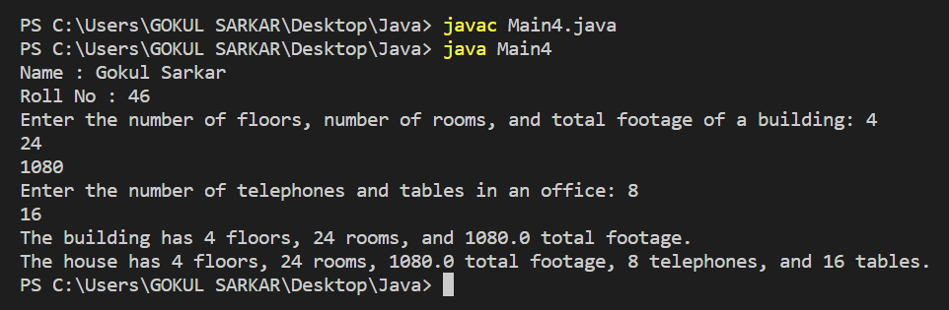

**4. Create a base class Distance which stores the distance between two locations in miles and a method travelTime(). The method prints the time taken to cover the distance when the speed is 60 miles per hour. Now in a derived class DistanceMKS, override travelTime() so that it prints the time assuming the distance is in kilometres and the speed is 100 km per second. Demonstrate the working of the classes.**

import java.util.Scanner;

class Distance {

double distance;

public Distance(double distance) {

this.distance = distance;

}

public double getDistance() {

return distance;

}

public void setDistance(double distance) {

this.distance = distance;

}

public void travelTime() {

double time = distance / 60.0;

System.out.println("Time taken to travel " + distance + " miles at 60 miles per hour is " + time + " hours.");

}

}

class DistanceMKS extends Distance {

public DistanceMKS(double distance) {

super(distance);

}

public void travelTime() {

double time = distance / 100.0;

System.out.println("Time taken to travel " + distance + " kilometers at 100 kilometers per hour is " + time + " hours.");

}

}

public class Main5 {

public static void main(String[] args) {

System.out.println("Name : Gokul Sarkar \nRoll No : 46");

Scanner scanner = new Scanner(System.in);

System.out.print("Enter the distance in miles: ");

double l = scanner.nextDouble();

Distance distance = new Distance(l);

distance.travelTime();

System.out.print("Enter the distance in miles: ");

double k = scanner.nextDouble();

DistanceMKS distanceMKS = new DistanceMKS(k);

distanceMKS.travelTime();

}

}

**Output:**

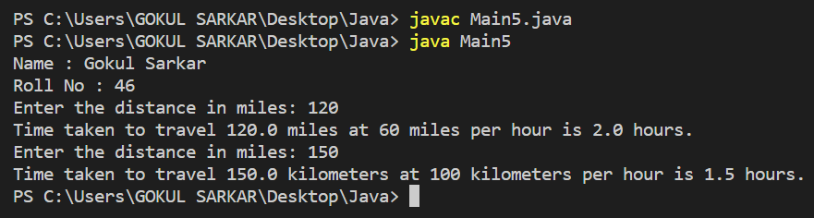

**5. Create a base class called “vehicle” that stores number of wheels and speed. Create the following derived classes –“car” that inherits “vehicle” and also stores number of passengers. “truck” that inherits “vehicle” and also stores the load limit. Write a main function to create objects of these two derived classes and display all the information about “car” and “truck”. Also compare the speed of these two vehicles - car and truck and display which one is faster.**

class Vehicle {

protected int numWheels;

protected double speed;

public Vehicle(int numWheels, double speed) {

this.numWheels = numWheels;

this.speed = speed;

}

public void printInfo() {

System.out.println("Number of wheels: " + numWheels);

System.out.println("Speed: " + speed + " kph");

}

}

class Car extends Vehicle {

private int numPassengers;

public Car(int numWheels, double speed, int numPassengers) {

super(numWheels, speed);

this.numPassengers = numPassengers;

}

public void printInfo() {

super.printInfo();

System.out.println("Number of passengers: " + numPassengers);

}

}

class Truck extends Vehicle {

private double loadLimit;

public Truck(int numWheels, double speed, double loadLimit) {

super(numWheels, speed);

this.loadLimit = loadLimit;

}

public void printInfo() {

super.printInfo();

System.out.println("Load limit: " + loadLimit + " ton");

}

}

public class Main6 {

public static void main(String[] args) {

System.out.println("Name : Gokul Sarkar \nRoll No : 46");

Car car = new Car(4, 160, 4);

car.printInfo();

Truck truck = new Truck(6, 90, 10000);

truck.printInfo();

if (car.speed > truck.speed) {

System.out.println("The car is faster than the truck.");

} else if (car.speed < truck.speed) {

System.out.println("The truck is faster than the car.");

} else {

System.out.println("The car and truck have the same speed.");

}

}

}

**Output:**

